**WORKING WITH CONSTRAINTS**

**EXPERIMENT:4 DATE:14-08-2024**

Find the Solution for the following:

1. Add a table-level PRIMARY KEY constraint to the EMP table on the ID column.The constraint should be named at creation. Name the constraint my_emp_id_pk.

**CREATE TABLE EMP2 ( ID NUMBER(7),**

**LAST_NAME VARCHAR2(25) NOT NULL, FIRST_NAME VARCHAR2(25) NOT NULL,**

# CONSTRAINT my_emp_id_pk PRIMARY KEY (ID));

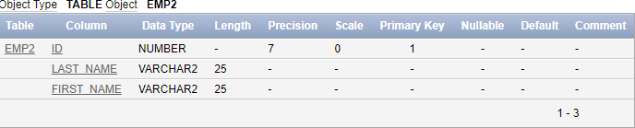

1. Create a PRIMAY KEY constraint to the DEPT table using the ID column. The constraint should be named at creation. Name the constraint my_dept_id_pk.

**CREATE TABLE DEPT2( ID NUMBER(7) NOT NULL,**

**DEPT_NAME VARCHAR2(50),**

# CONSTRAINT my_dept_id_pk PRIMARY KEY (ID));

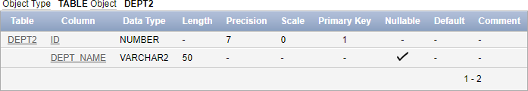

1. Add a column DEPT_ID to the EMP table. Add a foreign key reference on the EMP table that ensures that the employee is not assigned to nonexistent deparment. Name the constraint my_emp_dept_id_fk.

**ALTER TABLE EMP2**

**ADD DEPT_ID NUMBER(7); ALTER TABLE**

# ADD CONSTRAINT my_emp_dept_id_fk FOREIGN KEY (DEPT_ID) REFERENCES DEPT2(ID);

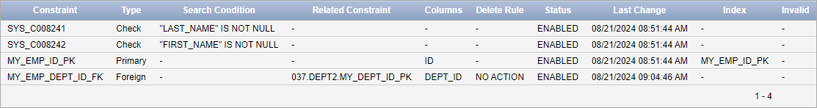

1. Modify the EMP table. Add a COMMISSION column of NUMBER data type, precision

2, scale 2. Add a constraint to the commission column that ensures that a commission value is greater than zero.

**ALTER TABLE EMP2**

**ADD COMMISSION NUMBER(2, 2); ALTER TABLE EMP2**

**ADD CONSTRAINT check_commission_positive CHECK (COMMISSION > 0);**

